
DEPARTMENT OF COMPUTER SCINCE & ENGINEERING
REPORT OF VAC
Course Code | 22IS01
Title of Value added Course | Angular JS
Total No. of Hours | 30
Academic Year | 2021-22
Period of course | 30Hrs
Whether VAC is available in curriculum? | No
Faculty handling the course | PADMINI.M
No. of Students Registered/Enrolled | 34
No. of Students completed the course and certified | 34
% of students completed the course | 100
Details of the course | The Students were taught the basics of Angular JS and how to use the computing techniques to develop the real world applications.
Outcome of the course | The students will be able to create the model for various applications.
CO Attainment | 3

CO-PO Attainment:
CO/PO | PO1 | PO2 | PO3 | PO4 | PO5 | PO6 | PO7 | PO8 | PO9 | PO10 | PO11 | PO12 | PSO1 | PSO2
CO 1 | 3 | 2 | 2 | 2 | 3 | 1 | 1 | 1 | 1 | 1 | 1 | 2 | 3 | 1

Faculty In charge HOD-CSE PRINCIPAL

Submitted to the Principal:
I hereby request you to give permission to conduct a Value Added Course titled “ANGULAR JS”, for the VII semester B.E CSE students. The syllabus and schedule prepared by the course handling faculty of the proposed VAC is attached for reference.

Total No. of Hours for VAC – 30 Hours
Period of VAC – 5 Days
Course co-ordinator:
Prof. PADMINI.M

HOD-CSE PRINCIPAL

CIRCULAR
A Value Added Course titled “ANGULAR JS” will be conducted for the VII semester students of B. E CSE from 26.09.22 to 30..09.22. Interested students are requested to register their names to Prof.Syed Zabiulla on or before 23.09.22.

Total No. of Hours for VAC – 30 Hours.
Period of VAC-5 Days

Faculty Co-ordinator HOD/CSE
        ValueAddedCourse On  QUANTUMCOMPUTING  26-09-2023to30-09-2023  COORDINATOR  PADMINI.M,CSE-KNSIT    Organisedby  Department of ISE KNSInstituteofTechnology Thirumenahalli,Bangalore-64 |  | ABOUTTHECOLLEGE  K.N.S Institute of technology was established in the year2001 by Sri C.K Jaffer Sharief, Former Union RailwayMinister, andGov ofIndia inthe memoryofhis SonLate.Sri Khader Nawaz Sharief and was inaugurated on 17thOctober 2002, in the presence of Shri Late Dr. RajaRamanna, renowned Scientist of World repute and firstchairman of KNSIT Governing council, Dr. Natarajanformer Chairman AICTE, New Delhi, Dr. K. Reddy,former Vice-Chancellor Visvesvaraya TechnologicalUniversity,Belagavi.KNSITisbuiltonasprawling20acrecampus with Superior infrastructure. The vibrant campusoftheinstitutionwasdesignedtogivemorelearningspaceto students. There has been continuous work towards thegrowth and development of the institution to compete inthe global technological challenges.  ABOUTTHEDEPARTMENT  Department of InformationScience & Engineering startedits4 yearB.ECourseinthe year2001withanintakeof60students. The Department has well equipped laboratorieswith state of art computational facility. The Departmenthas highly qualified and dedicated faculty members withrich experience in teaching and research. Our goal is notonlytoteachthestudents,howtousetheoreticalaspectstobuild applicationin future to meet industry standards. Thedepartment has been organizing conferences, workshops,seminars and students key activities to encourage thestudents and faculties tocommit lifelonglearningprocess.Students are also encouraged to participate in state andnational level completion covering academics, culturalactivities and also trained to become entrepreneur.  Department is committed for creating the students thatreflects the diversity of world we live in, contributing toeducationalexcellenceanddynamiccampusenvironment. |  | OBJECTIVEOFTHE COURSE  ToImpactQuantumComputingTechniques&Skillstosolve for Real world problem.  TOPICSTOBECOVERED  - Introduction to Angular JS  - Features of Angular JS  - Data Binding  - Dependency Injection  - Scope  - Angular JS Directives  - MVC  - Advantages and disadvantages of Angular JS  - Angular JS Applications  - Angular JS Strings,arrays and expressions  Organizingcommittee  Patron  Dr. S.M.Prakash  Principal,KNSIT  Convener  Dr.SureshH  HeadofISEDepartment,KNSIT  CourseHandlingFaculty  JitheshKurian  CooperateTrainer&Domainexpert.

Course Code
Title of Value Added Course | ANGULAR JS
Total No.of Hours | 30

SYLLABUS
OBJECTIVES:
To impact ANGULAR JS techniques and skills to solve for real time problems.
Exercise:
SL.NO | TOPIC | Hours per Day: 6 Hrs
1. | Introduction to Angular JS What is Angular JS ?Why is Angular JS ?  Structure, Quality and Organization • Lightweight • Free • Separation of concern • Modularity • Extensibility & Maintainability • Reusable Components | 1
2 | Features of Angular JS Two-way Data Binding • Scope −Controller Services Modeller Viewer Controller (MVC) Directives | 2
3 | Data Binding Synchronization between the model and the view. • Two-way Binding : When data in the model changes, the view reflects the change, and when data in the view changes, the model is updated as well. | 3
4 | Dependency Injection Is a software design in which components are given their dependencies instead of hard coding them within the component • Relieves a component from locating the dependency and makes dependencies configurable Core components which can be injected into each other as dependencies • Value • Factory • Service • Provider • Constant | 4
5 | Scope Scope is a special JavaScript object that connects controller with views • Scope contains model data • In controllers, model data is accessed via $scope object • The $scope is passed as first argument to controller during its constructor definition | 5

OUTCOME:
At the end of the course, the students will be able to
CO1 | Apply the skills learnt to provide solutions for the Real-World problems in various fields of Engineering.

SCHEDULE
Course Code
Title of Value Added Course | ANGULAR JS
Total No. Of Hours | 30
Academic year | 2022-23

Sl.No | Date | No. of Hours | Time | Topic/Exercise
 |  | 6 | 9am to12 pm  & 1-00 to 3.00 | Introduction to Angular Features of Angular JS Two-way Data Binding • Scope −Controller Services Modeller Viewer Controller (MVC) Directives –
 |  | 6 | 9am to12 pm  & 1-00 to 3.00 | Data Binding Synchronization between the model and the view.  • Two-way Binding :
 |  | 6 | 9am to12 pm  & 1-00 to 3.00 | Dependency Injection Is a software design in which components are given their dependencies instead of hard coding them within the component
 |  | 6 | 9am to12 pm  & 1-00 to 3.00 | • Relieves a component from locating the dependency and makes dependencies configurable Core components which can be injected into each other as dependencies • Value • Factory • Service • Provider • Constant
 |  | 6 | 9am to12 pm  & 1-00 to 3.00 | Scope Scope is a special JavaScript object that connects controller with views • Scope contains model data • In controllers, model data is accessed via $scope object • The $scope is passed as first argument to controller during its constructor definition
SCHEDULE OF ASSESSMENTS:
SL.NO | Date | No. of Hours | Time | Details
1 | 30-9-22 | 1 | 3 to 4 pm | Assessment

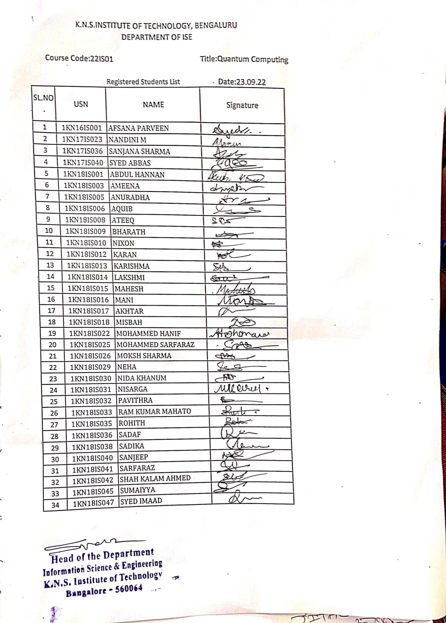
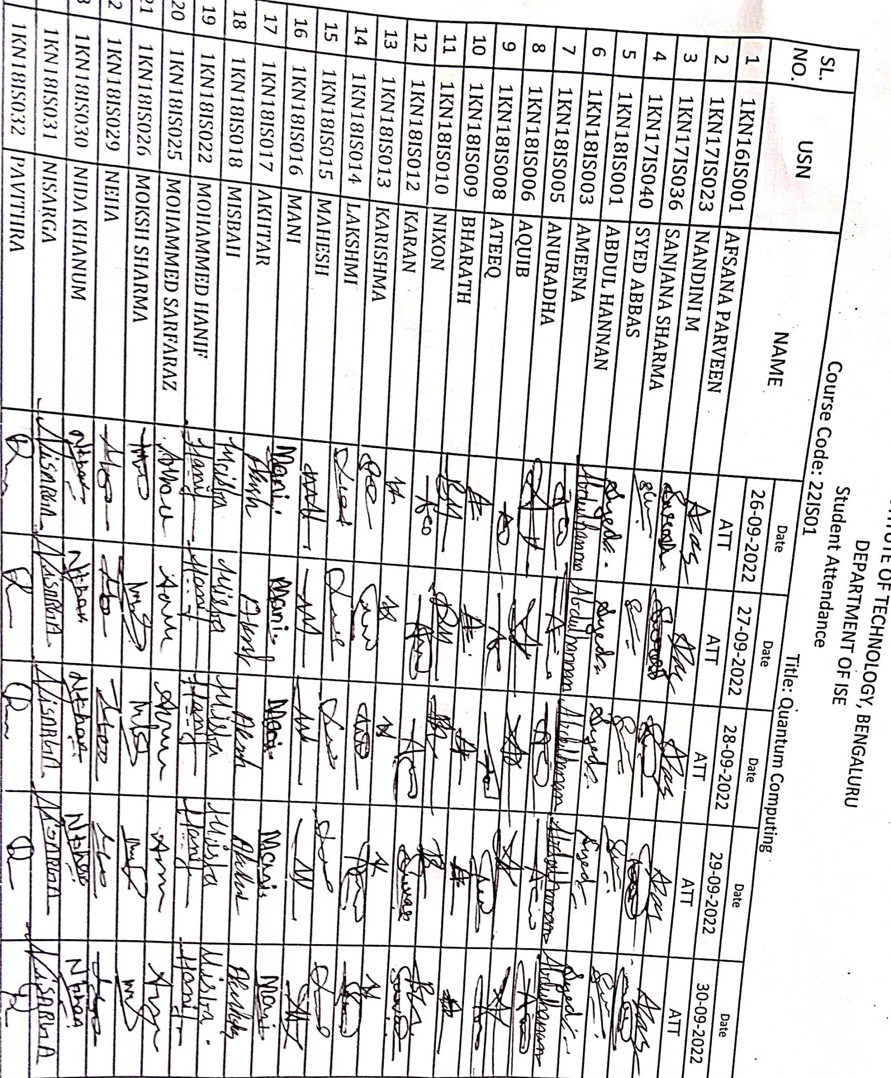

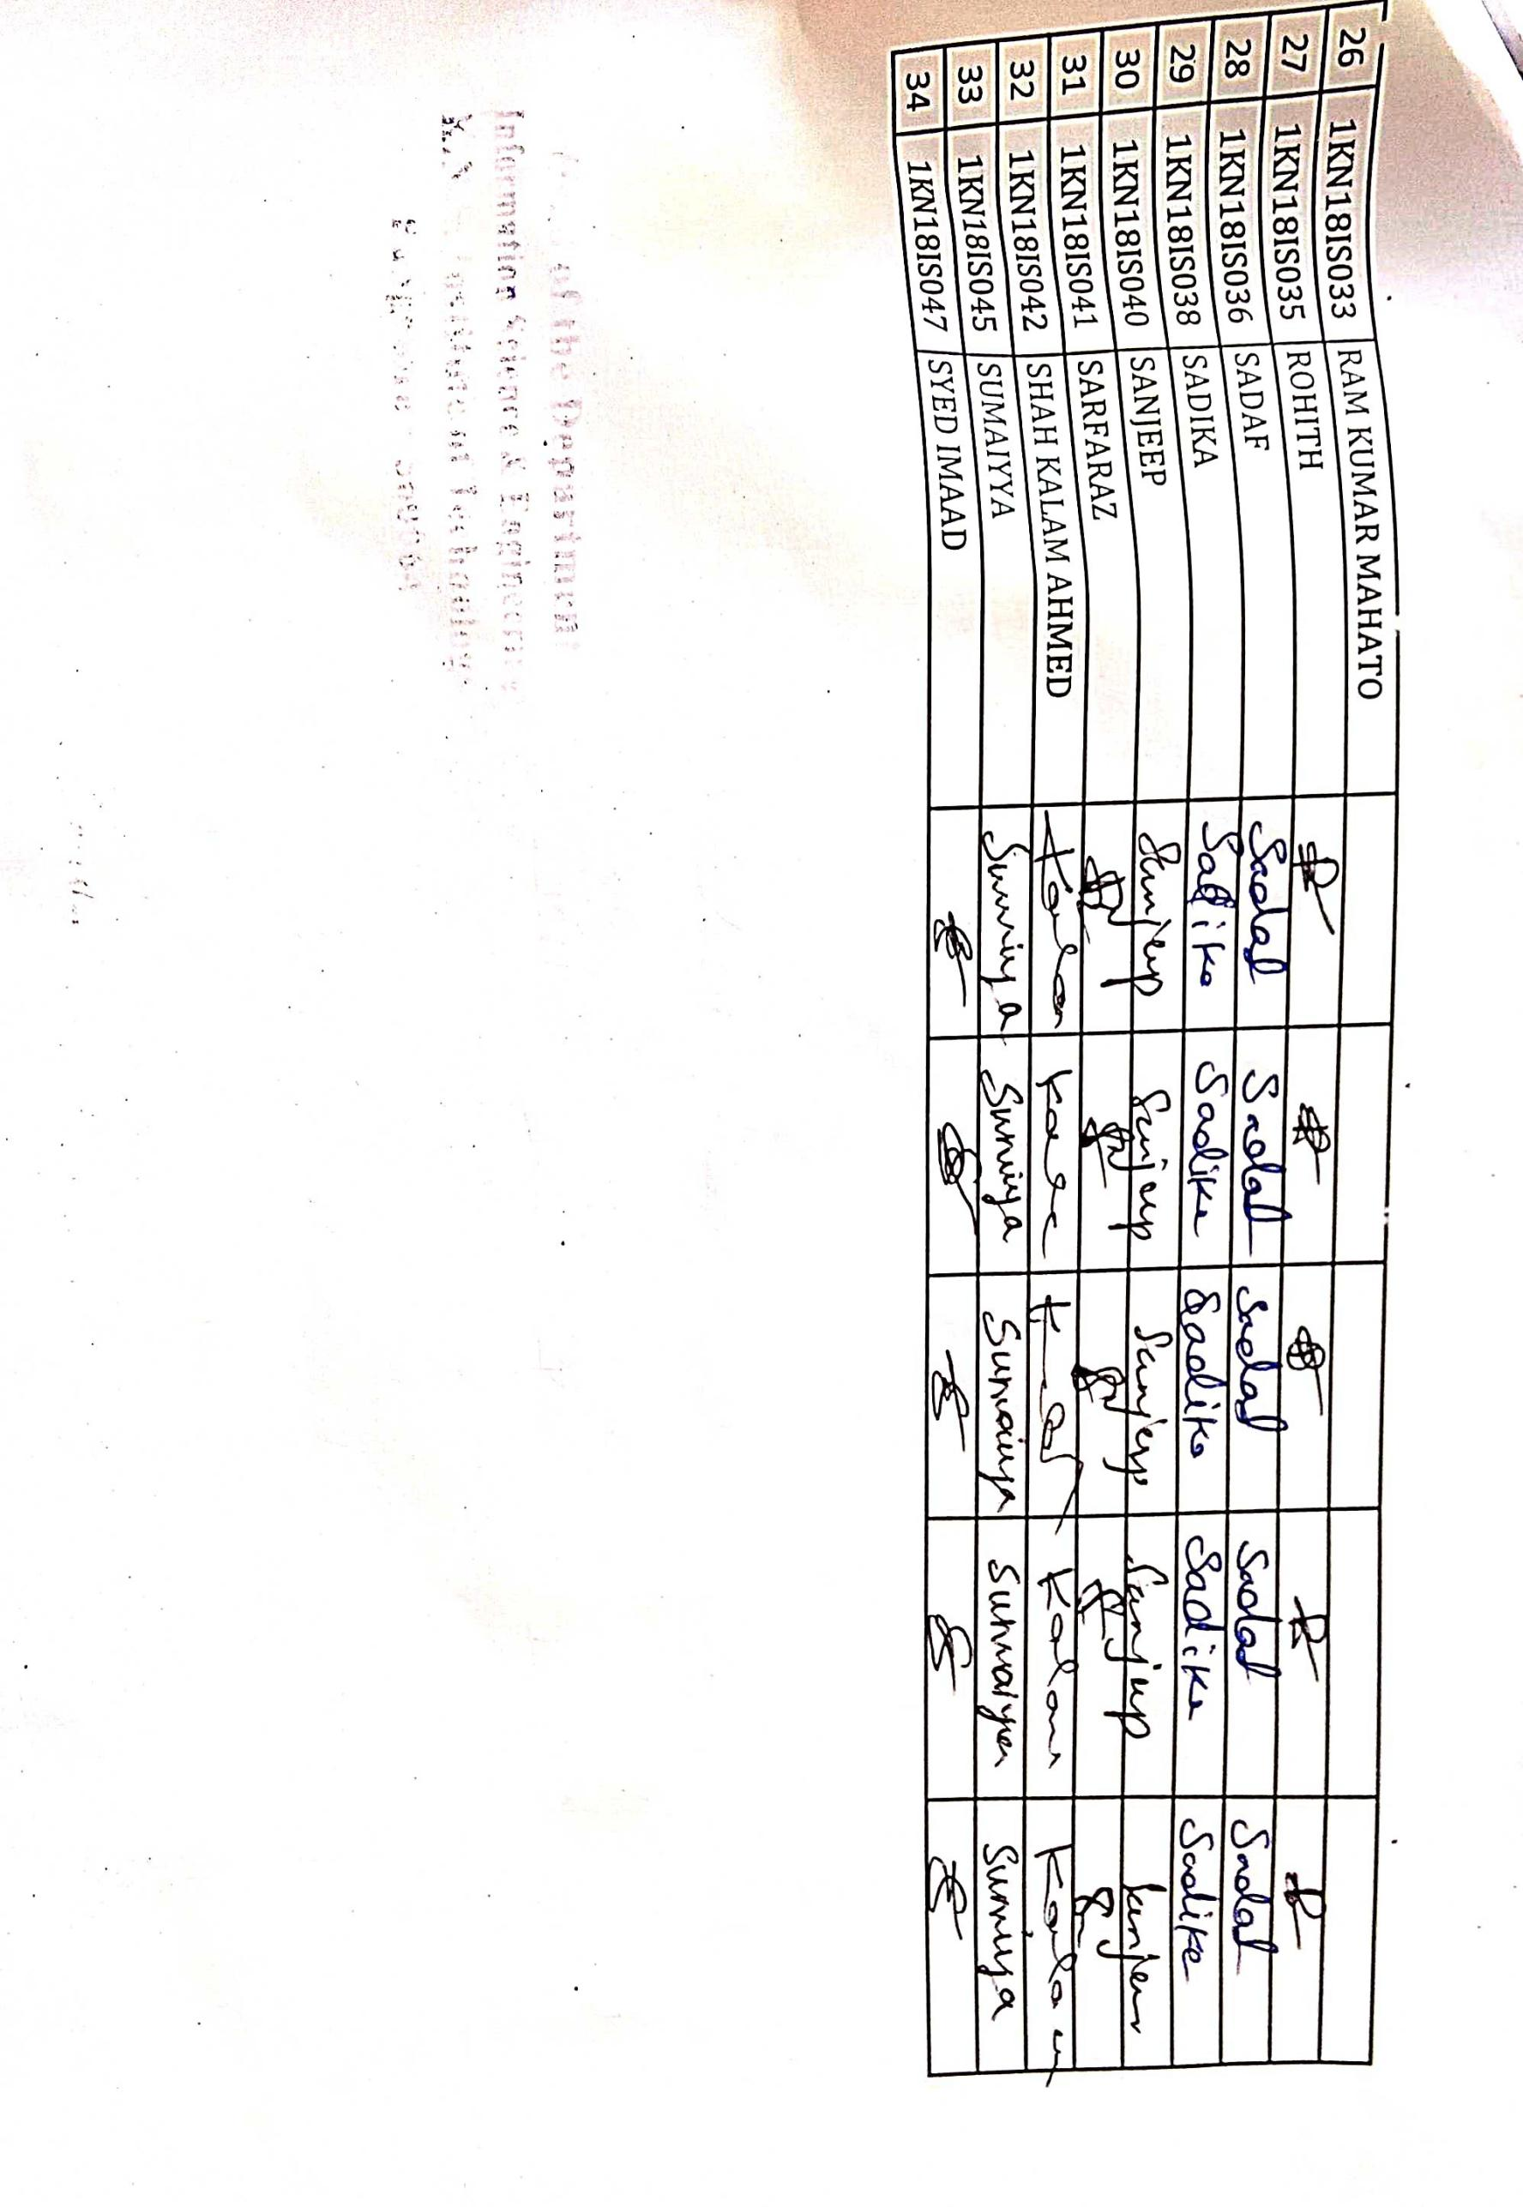

 | KNS Institute of Technology  Thirumenna Halli hegde Nagar Bangalore
DEPARTMENT OF CSE

Q. NO | QUESTION | ANS
1. | Angular JS is a ____  - Java framework  - JavaScript framework  - HTML framework  - SQL framework | b
2. | Angular JS is perfect for?  - MPAs  - DPAs  - CPAs  - SPAs | d
3. | Among the following, on which architectural pattern is Angular JS based?  - Decorator pattern  - Observer pattern  - MVVM architecture pattern  - MVC architecture pattern | c
4. | State whether true or false: Angular JS provides reusable components  - True  - False | a
5. | Choose the correct syntax for writing Angular JS expression.  - [expression]  - {{expressions}}  - {{{expressions}}}  - {expressions} | b
6. | Choose the reactor which is used to bind the application data to the HTML view in Angular JS.  - ng-bind directive  - ng-model directive  - ng-init directive  - ng-app directive | a
7. | Choose the correct statement about the lowercase filter.  - it is a function that takes text as input  - the lowercase filter converts a text to lowercase text  - both a and b  - none of the above | b
8. | Choose the advantage of Angular JS among the following.  - it provides reusable components  - it uses dependency injection and makes use of separation of concerns  - it is unit-testable  - all of the above | d
9. | The functionality of angular controllers in the application is  - an angular controller is used for displaying the data  - an angular controller is used for controlling the data  - both a and b  - None of the above | b
10. | The syntax used to create a module in Angular JS is:  - module(“app”,[])  - var myModule=angular.module();  - var myModule = new Module();  - None of the above | a
11. | Choose the incorrect Angular JS filter.  - orderby  - email  - currency  - lowercase | b
12. | Who is the father of Angular JS?  - Misko Hevery  - Brad Green  - Mike Adams  - Adam a bronze | a

13. | Choose the directive which is used to find the values of HTML controls to application data.  - ng-model  - ng-init  - ng-app  - ng-hide | a
14. | Choose whether true or false: Angular JS is completely based on HTML and JavaScript.  - True  - False | a
15. | Module created by using Angular JS function is known as  - module()  - mod()  - Angular module()  - mdl() | b
16. | The total $RootScope an Angular JS application can have is?  - 0  - 1  - 2  - 3 | b
19. | Among the following which can be used to write AngularJS directives  - Attribute  - class name  - Tag  - all of the above | d
20. | State whether true or false: $routeprovider is a module.  - True  - False | a
21. | State whether true or false: $https Services used to make an Ajax call to the server.  - True  - False | a
22. | AOT stands for ________  - Angular Object Templates  - Ahead of Time compilation  - Both a and b  - None of the above | b
23. | Choose the incorrect hook application lifecycle.  - noOnInit  - ngViewStart  - ngOnChanges  - None of the above | b
24. | The router is a part of which of the following given models?  - @angular/router  - @angular/core  - Both a and b  - None of the above | A
25. | What can RxJS be used for?  - Server-side  - Browser  - Both a and b  - None of the above | c

Course Code | 21IS01
Title of Value Added Course | Angular JS
Total No. Of Hours | 30
Academic year | 2022-23
STUDENT MARK LIST
 | USN | NAME | MARKS (100)
1 | 1KN16IS001 | AFSANA PARVEEN
2 | 1KN17IS023 | NANDINI M
3 | 1KN17IS036 | SANJANA SHARMA
4 | 1KN17IS040 | SYED ABBAS
5 | 1KN18IS001 | ABDUL HANNAN
6 | 1KN18IS003 | AMEENA
7 | 1KN18IS005 | ANURADHA
8 | 1KN18IS006 | AQUIB
9 | 1KN18IS008 | ATEEQ
10 | 1KN18IS009 | BHARATH
11 | 1KN18IS010 | NIXON
12 | 1KN18IS012 | KARAN
13 | 1KN18IS013 | KARISHMA
14 | 1KN18IS014 | LAKSHMI
15 | 1KN18IS015 | MAHESH
16 | 1KN18IS016 | MANI
17 | 1KN18IS017 | AKHTAR
18 | 1KN18IS018 | MISBAH
19 | 1KN18IS022 | MOHAMMED HANIF
20 | 1KN18IS025 | MOHAMMED SARFARAZ
21 | 1KN18IS026 | MOKSH SHARMA
22 | 1KN18IS029 | NEHA
23 | 1KN18IS030 | NIDA KHANUM
24 | 1KN18IS031 | NISARGA
25 | 1KN18IS032 | PAVITHRA
26 | 1KN18IS033 | RAM KUMAR MAHATO
27 | 1KN18IS035 | ROHITH
28 | 1KN18IS036 | SADAF
29 | 1KN18IS038 | SADIKA
30 | 1KN18IS040 | SANJEEP
31 | 1KN18IS041 | SARFARAZ
32 | 1KN18IS042 | SHAH KALAM AHMED
33 | 1KN18IS045 | SUMAIYYA
34 | 1KN18IS047 | SYED IMAAD

Faculty Handling the course HOD-CSE PRINCIPAL


VALUE ADDED COURSE
ON
Angular JS
---------------------------------------------------------------------------------------------------------------------------------------------
Has attended and completed the value Added Course titled “ANGULAR JS, conducted by the Department of COM SCIENCE & ENGINEERING,KNS Institute OF Technology, Bangalore from 26th September 2022-30th September 2022 .

VAC-CO ORDINATOR HOD-ISE PRINCIPAL

